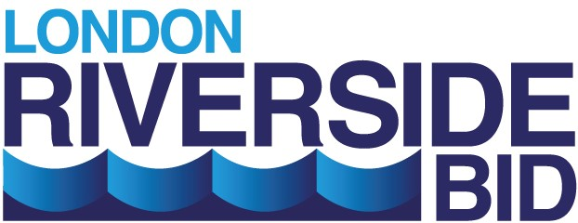
London Riverside (BID) Limited
PROXY VOTING FORM - 9th September 2021

*I / we hereby nominate the Chairman of the meeting or
………………………………………………………………………………………………..
to vote on my / our behalf at the Annual General Meeting of London Riverside (BID) Limited (“LRB”) which will be held at CEME, Marsh Way, Rainham, Essex RM13 8EU at 9am on Thursday 9th September 2021
I / we confirm that l / we are Member(s) of LRB
Name of Business:
...........................................................................………………………………………...….

Address: ……………………………………………………………………………………………………..
Name: ……………………………………………………………………………………………………..
Signature: …………………………………………………… Date:...…………………………...
Notes:
*A person completing this form on behalf of a business must be a Member of LRB
A person holding a Proxy Voting Form need not be a member of LRB
Proxies must be received and registered with LRB by post or email at least 7 (seven) days prior to the above AGM.

Please send to:
London Riverside (BID) Limited, 1st Floor, Recycling House, Ferry Lane, Rainham, RM13 9DB or email to info@londonriversidebid.co.uk

